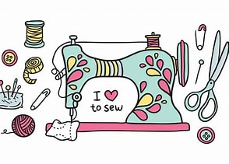
Charity Sew Day
Join us Thursday, 11/20/25 and Friday, 11/21/25, for a sew day! We will be making quilts for the children living in Mid-Coast Family Crisis Center’s family shelter. Bring your sewing machine and sewing supplies. I will bring some of the three-yard quilt patterns which you are welcome to use. Please bring three one-yard cuts of coordinating fabrics, or you can use one of the sets I have kitted up. Everyone is welcome to come and participate!

